**EXTERNAL PRESSURE SENSOR INTERFACE USING USB COMMUNICATION**

**A INTERNSHIP REPORT**

***Submitted by***

**VIKRAM PHANI AMBATIPUDUI**

**210130111055  
*In partial fulfilment for the award of the degree of***

**BACHELOR OF ENGINEERING**

**in**

**ELECTRONICS AND COMMUNICATION**

******Government Engineering College, Sector-28, Gandhinagar**

**Gujarat Technological University, Ahmedabad**

**APRIL, 2025**



**GOVERNMENT ENGINEERING COLLEGE GANDHINAGAR Nr. Animal Vaccine Institute, Sector-28, Gandhinagar, Gujarat**

**CERTIFICATE**

This is to certify that the project report submitted along with the project entitled **External Pressure sensor interface using USB Communication** has been carried out by **Vikram Phani Ambatipudi** under my guidance in partial fulfilment for the degree of Bachelor of Engineering in , 8th Semester of Gujarat Technological University, Ahmadabad during the academic year 2024-25.

Prof. Sandip. J. Dawda Prof. Tejas B. Sheth

Internal Guide Head of the Department

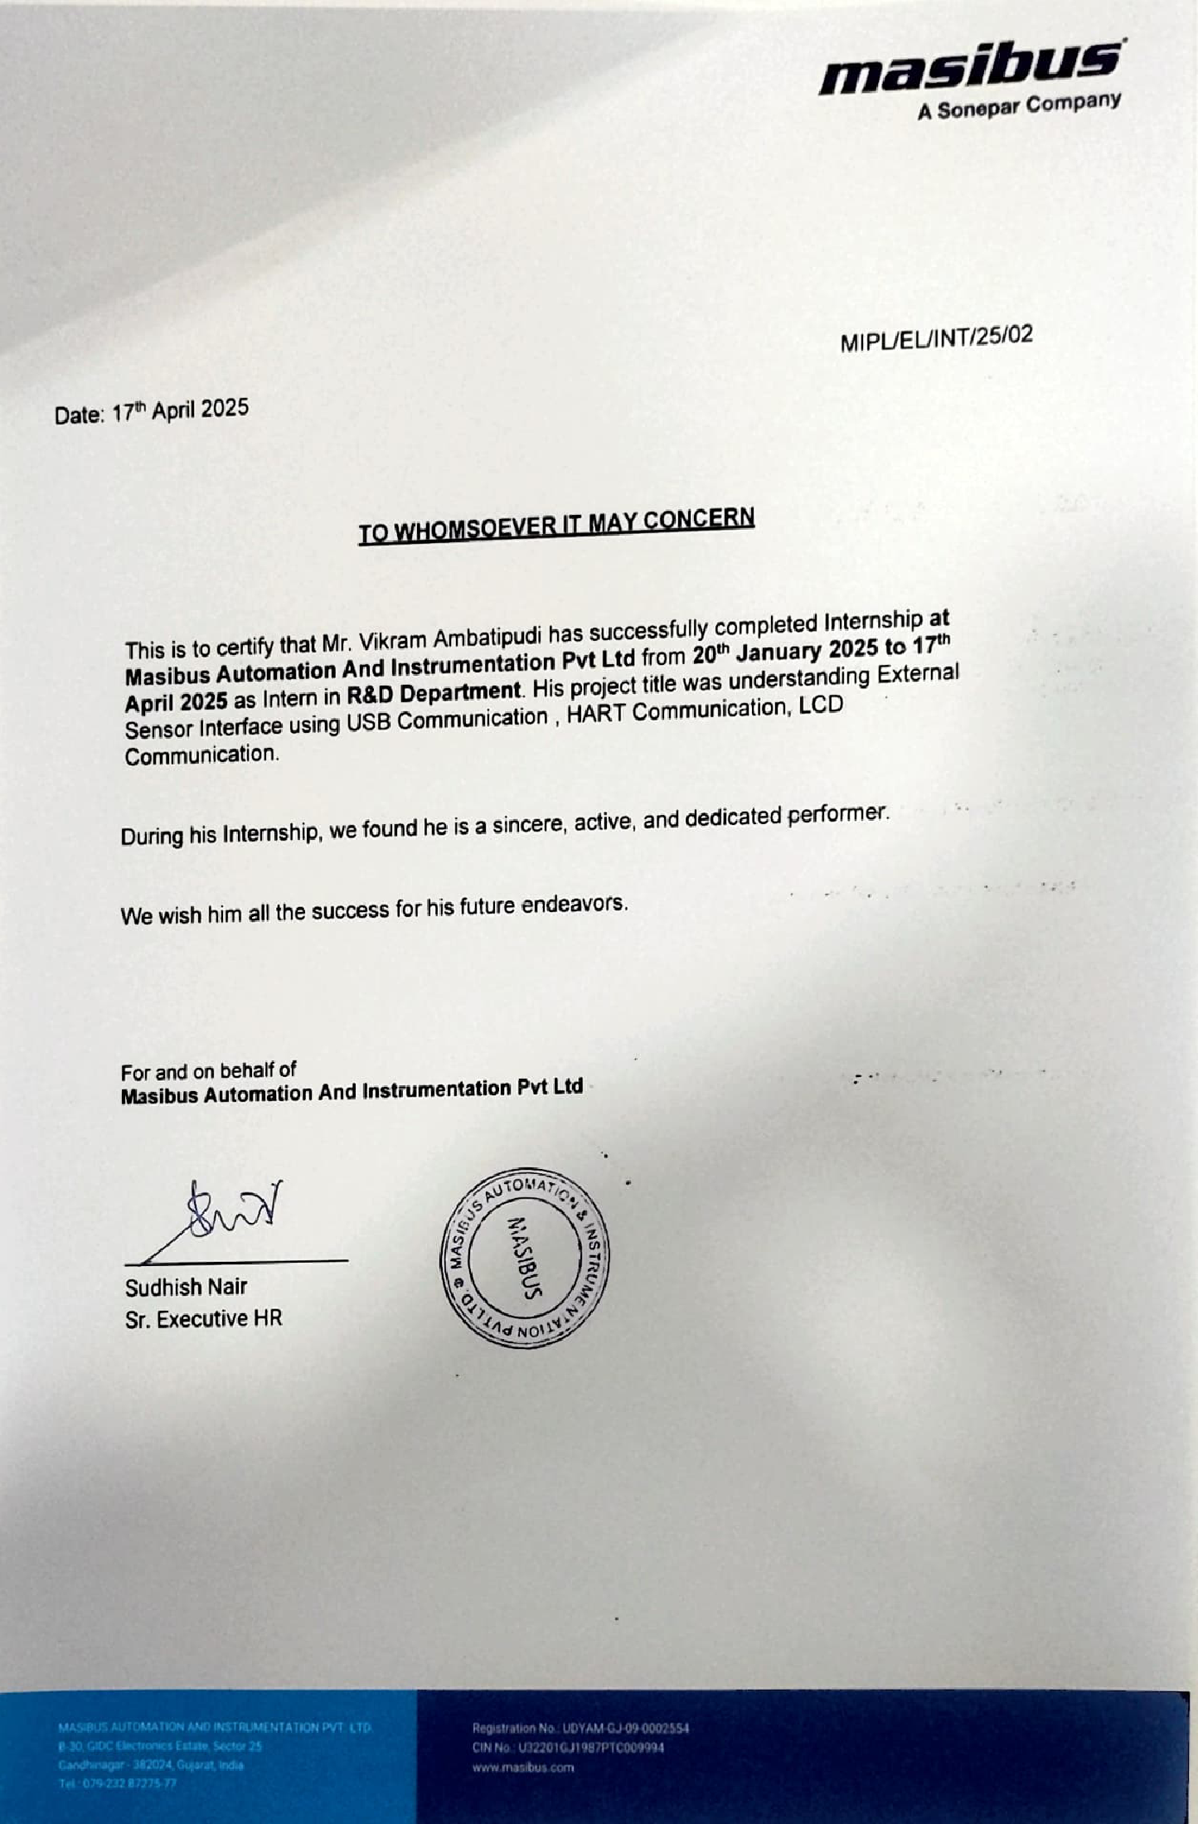**INDUSTRY CERTIFICATE**



**GOVERNMENT ENGINEERING COLLEGE GANDHINAGAR, Sector-28, Gandhinagar, Gujarat**

Declaration

We hereby declare that the Internship report submitted along with the Internship entitled **External Pressure Sensor Using USB Communication** submitted in partial fulfilment for the degree of Bachelor of Engineering in **Electronics and Communication** to Gujarat Technological University, Ahmedabad, is a Bonafide record of original project work carried out by me at under the supervision of and that no part of this report has been directly copied from any students’ reports or taken from any other source, without providing due reference.

Name of student Sign of student

Vikram Phani Ambatipudi _________________________

Acknowledgement

The final phase of our bachelor’s degree has given us the opportunity to explore practical aspects of engineering through hands-on training and project work. I am sincerely thankful to Government Engineering College, Gandhinagar for providing a strong academic foundation and a platform to grow professionally and providing the resources and academic environment necessary to carry out this work. I would like to express my heartfelt gratitude to my mentor, Khyati Jasani, for her constant guidance and support throughout the project. I am also thankful to Masibus Automation and Instrumentation Pvt. Ltd. for providing me with an opportunity to work in an industrial environment, which greatly enriched my technical skills and practical knowledge.

Abstract

During the course of this internship at **Masibus Automation and Instrumentation Pvt. Ltd.**, a comprehensive study and practical implementation of sensor interfacing and USB communication protocols was undertaken. The core focus of the project was to design and develop an **External Pressure Interface** capable of reading sensor data and transmitting it to a host system via USB.

The internship began with a foundational understanding of industrial sensor systems, particularly pressure transmitters and their digital calibration techniques. With guidance from experienced professionals, significant emphasis was placed on learning how to interface these sensors with microcontrollers and how to handle digital data transfer using USB protocols.

The project involved developing firmware using **Code Composer Studio (CCS)** for a microcontroller based on the **ARM Cortex-M4** architecture. Core components included setting up communication buffers, handling USB endpoints, and designing a reliable data flow from the sensor to the host system.

Through this internship, theoretical concepts in embedded systems and digital communication were successfully applied in a real-world industrial context. The outcome was a working prototype that not only enabled accurate pressure monitoring but also adhered to industrial standards of data integrity and reliability.

List of Figures

Figure 1.1 Logo 1

Figure 1.2 Services 3

Figure 2.1 HART Communication 7

Figure 3.1 Internship flow chart 9

Figure 4.1 UC12 Figure 11

Figure 4.2 UC12 Figure 11

Figure 4.3 UC 12 internal Figure 11

Figure 4.4 UC 12 USB port 12

Figure 4.5 UC 12 Old Display 13

Figure 5.1 UC 12 basic working 16

Figure 5.2 New Block Diagram of Multifunctional calibrator 17

Figure 5.3 Debugger and Connection 18

Figure 6.1 CCS UI 19

Figure 6.2 Commands supported by pressure sensor 20

Figure 6.3 USB packet list 21

Figure 6.4 Mouse Setup 21

Figure 6.5 Position in serial monitor 22

Figure 6.6 UC 12 connection with another board 23

Figure 6.7 HART device calibration 24

Figure 6.8 New LCD 26

Figure 6.9 Command Example 26

Figure 6.10 Home screen of LCD 27

List of Abbreviation

**UC 12 Universal Calibrator**

**USB Universal Serial Bus**

**PLCs Programmable Logic Controllers**

**SCADA Supervisory Control and Data Acquisition**

**HMI Human-Machine Interface**

**HART Highway Addressable Remote Transducer**

**DD Device Description**

**DDL Device Description Language**

**CCS Code Composer Studio**

**UART Universal Asynchronous Receiver/Transmitter.**

**OTG On the GO Mode**

TABLE OF CONTENTS

Declaration i

Acknowledgement ii

Abstract iii

List of Figures iv

List of Abbreviation v

TABLE OF CONTENTS vi

CHAPTER 1 Organization Profile 1

1.1. History 1

1.2. Different Product / Scope of Work 1

1.2.1. Process Control Instruments 1

1.2.2. Data Acquisition & Logging Systems 2

1.2.3. Calibrators and Test Equipment 2

1.2.4. Sensors and Transmitters 2

1.2.5. Remote Monitoring and IoT 2

1.2.6. Custom System Integration 2

1.2.7. Power and Energy Monitoring 3

1.3. Capacity of Plant 3

CHAPTER 2: INTRODUCTION TO INTERNSHIP & PROJECT 5

2.1. Project Summary 5

2.2. Purpose: 5

2.3. Objective of Internship 5

2.4. Scope 6

2.5. Techonological and Litrature Review 6

2.5.1. Microcontroller-Based Calibration Systems 6

2.5.2. Sensor Interface and Data Acquisition 6

2.5.3. HART Communication Protocol 6

2.5.4. LCD Display in Embedded Systems 7

CHAPTER 3 PROJECT & INTERNSHIP PLANNING 8

3.1. Planning 8

3.1.1. Identifying Deliverables 8

3.1.2. Scheduling Resources: 8

3.1.3. Organizing Staff: 8

3.1.4. Risk Management: 8

3.2. Work Plan During Internship: 9

Chapter 4: PRODUCT OVERVIEW 10

4.1. Study of UC 12 (Current system) 10

4.1.1. Some key features are as follow: 10

4.1.2. Purpose of Study: 10

4.2. Problem and Weaknesses of UC 12 (Current System) 12

4.3. Requirements of New System 13

4.4. System Feasibility 14

4.5. List Main Modules 14

CHAPTER 5: System Design 16

**5.** 16

5.1. System Design & Methodology 16

5.2. Block diagram 17

5.3. Interface Design 17

5.3.1. USB 17

5.3.2. HART interface 18

5.3.3. LCD 18

CHAPTER 6: IMPLEMENTATION 19

6.1. Implementation Platform 19

6.1.1. Hardware Environment: 19

6.1.2. Software Environment: 19

6.2. Implementation Process 20

6.2.1. Phase 1 – External Sensor Interface: 20

6.2.2. Phase 2 - HART communication 23

6.2.3. Phase 3 – LCD interface 25

CHAPTER 7: CONCLUSION 28

7.1. Overall Analysis of Internship / Project Viabilities 28

7.2. Problem Encountered and Possible Solutions 29

7.3. Conclusion 29

7.4. References 30

POSTER 31

# CHAPTER 1 Organization Profile



## History

Figure 1.1 Logo



Masibus Automation and Instrumentation Pvt. Ltd. commenced operations in 1975 as a modest enterprise with a small team. Over the years, it has expanded into a significant organization with a workforce exceeding 200 employees. The company specializes in industrial automation and instrumentation solutions, serving over 20,000 customers across approximately 50 industrial sectors. Its product and service offerings are delivered through eight regional offices and an extensive network of dealers and system integrators. Currently,

Masibus is headquartered in Gandhinagar, Gujarat, India, with additional facilities in Goa and Sharjah, United Arab Emirates.



## **Different Product / Scope of Work**

Masibus Automation and Instrumentation Pvt. Ltd. is a well-established Indian company specializing in the design and manufacture of industrial automation and instrumentation products. Since its inception in 1975, the company has expanded its offerings to serve a wide range of industrial sectors, including manufacturing, energy, pharmaceuticals, chemicals, and infrastructure.

Here are the key product categories and scope of work of Masibus:

### Process Control Instruments

* + - 1. Indicators and Controllers: Digital indicators, temperature controllers, PID controllers, loop controllers for monitoring and regulating process parameters like temperature, pressure, and flow.
      2. Programmable Logic Controllers (PLCs): Customizable control units for automating industrial processes with high precision.
      3. Isolators and Transmitters: Used for signal conditioning, electrical isolation, and reliable transmission of analog and digital signals.

### Data Acquisition & Logging Systems

* + - 1. Data Loggers: For collecting and recording process data over time, supporting compliance and analysis.
      2. SCADA and HMI Solutions: Supervisory Control and Data Acquisition systems for remote monitoring and control of industrial processes with real-time visualization

### Calibrators and Test Equipment

* + - 1. Multifunction Calibrators: Portable and bench-top devices used to calibrate sensors and transmitters for various parameters like temperature, pressure, and electrical signals.
      2. Loop Calibrators: Used to simulate and measure current in process control loops, useful for maintenance and diagnostics.

### Sensors and Transmitters

* + - 1. Temperature Sensors: Thermocouples, RTDs (Resistance Temperature Detectors), and transmitters for industrial temperature measurement.
      2. Pressure and Level Transmitters: Devices for measuring and transmitting process pressure and level data.

### Remote Monitoring and IoT

* + - 1. Industrial IoT Solutions: Cloud-connected devices and gateways for remote data access, predictive maintenance, and analytics.
      2. Wireless Transmitters and Monitoring: For installations where wiring is difficult or impractical, enabling flexible and scalable monitoring.

### Custom System Integration

* + - 1. Turnkey Automation Solutions: From sensor selection to final commissioning, Masibus offers end-to-end automation and instrumentation system integration tailored to client needs.
      2. Panel Building & Engineering Services: Control panel design, fabrication, and wiring for industrial and infrastructure applications.

### Power and Energy Monitoring

* + - 1. Energy Meters and Analysers: Solutions for monitoring, analysing, and optimizing energy consumption in industrial plants.
      2. Power Quality Monitoring Systems: To detect and address disturbances, imbalances, and inefficiencies in electrical systems.

Figure 1.2 Services

## Capacity of Plant

* + 1. Manufacturing Area: The primary facility spans over 40,000+ sq. ft. of built-up area, dedicated to assembly lines, testing labs, calibration stations, and storage.
    2. Production Capacity: The plant is capable of producing over 60,000+ units annually, covering various product lines such as indicators, controllers, transmitters, and calibrators.
    3. In-House Testing and Calibration: Equipped with automated test benches, environmental test chambers, and NABL-accredited calibration facilities for temperature, pressure, and electrical signals.
    4. Workforce Strength: More than 200 skilled professionals including engineers, technicians, and operators working in production, R&D, and QA departments.
    5. Scalability: The plant is designed for modular expansion to meet future demands and product diversification.

# CHAPTER 2: INTRODUCTION TO INTERNSHIP & PROJECT



## Project Summary

During my internship at Masibus Automation and Instrumentation Pvt. Ltd., I worked on interfacing external sensors with the company’s proprietary controller unit, UC 12, with a focus on real-time data acquisition and display. The project involved designing and implementing a communication interface between UC 12 and external temperature sensors to simulate and calibrate pressure signals.

As part of the development process, I also gained hands-on experience working with HART (Highway Addressable Remote Transducer) protocol, which is widely used in industrial field communication. I explored how HART enables digital communication over analog wiring Additionally, I worked on integrating an LCD display with the UC 12 unit for live sensor data visualization and status feedback. This required understanding register mapping, microcontroller-based interface logic, and optimizing the user interface for clear real-time readings.

## Purpose:

The purpose of this project is to design and implement an external sensor interface with the UC 12 calibrator developed by Masibus Automation and Instrumentation Pvt. Ltd., enabling accurate acquisition and calibration of sensor data. The project aims to enhance the functionality of the calibrator by integrating support for various external sensors and communication protocols like HART, along with real-time data display on an LCD. This contributes to improved versatility, reliability, and ease of use in industrial measurement and calibration applications.



## Objective of Internship

* + 1. To interface external sensors with the UC 12 calibrator.
    2. To understand and implement HART communication protocol.
    3. To integrate and program an LCD for real-time sensor data display.
    4. To gain hands-on experience with industrial calibration systems.
    5. To enhance skills in embedded systems and instrumentation.

## Scope

* + 1. Interface various external sensors (like temperature or pressure) with the UC 12 calibrator.
    2. Acquire real-time sensor data and display it on an LCD screen.
    3. Support basic communication using HART protocol.
    4. Provide a user-friendly interface for calibration and monitoring.
    5. Be used in lab testing and semi-industrial environments for sensor validation.
    6. It does not support advanced wireless communication or IoT/cloud connectivity.
    7. It cannot perform automatic fault detection or sensor diagnostics.
    8. It is not intended for use in hazardous or high-voltage industrial environments

## Techonological and Litrature Review

### Microcontroller-Based Calibration Systems

Microcontrollers form the core of most industrial calibration equipment. Devices like the UC 12 rely on embedded systems to read sensor inputs, process data, and output calibrated values. Studies highlight their reliability, low power consumption, and flexibility in handling multiple sensor types.

### Sensor Interface and Data Acquisition

Sensor interfacing involves connecting analog or digital sensors (e.g., temperature, pressure) to a controller and accurately reading their signals. Literature emphasizes the importance of ADC resolution, sampling rate, and noise filtering techniques for ensuring reliable data acquisition.

### HART Communication Protocol

HART (Highway Addressable Remote Transducer) is an industry-standard protocol used for digital communication with smart sensors over analog 4–20 mA current loops. Research shows that HART enables two-way communication, device diagnostics, and configuration without disrupting the analog signal. It is widely used in process control and instrumentation.

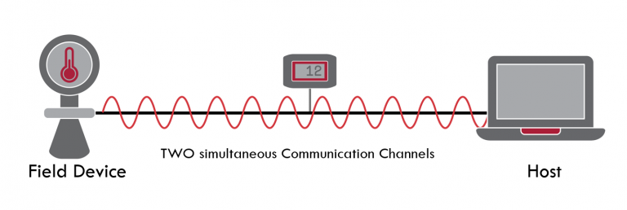

Figure 2.1 HART Communication

### LCD Display in Embedded Systems

LCDs (Liquid Crystal Displays) are used for real-time visualization of sensor data. Literature supports their use due to low power usage, ease of programming, and compatibility with microcontrollers. They enhance the user experience by providing clear and immediate feedback during sensor calibration and testing.

# CHAPTER 3 PROJECT & INTERNSHIP PLANNING



## Planning

The internship was planned with a structured timeline and key learning goals to align with both academic objectives and industry requirements. The planning was carried out in the following phases:



### Identifying Deliverables

* + - 1. Successful interfacing of temperature sensors with the UC 12 calibrator.
      2. Integration of HART communication for smart sensor compatibility.
      3. Real-time sensor data display on LCD.

### Scheduling Resources:

Software: Embedded C compiler, terminal monitor, simulation/testing tools, serial monitoring tools (hterm, teraterm)

### Organizing Staff:

Mentor: Company-assigned engineer with experience in calibrator development

### Risk Management:

* + - 1. Risk of sensor signal mismatch or hardware compatibility issue
      2. Delays in hardware availability or access to tools
      3. Complicated process of forming DD file of HART enabled device

## Work Plan During Internship:

Figure 3.1 Internship flow chart

Work plan in Internship had followed the above flow char for forming an end product (still in development).

# Chapter 4: PRODUCT OVERVIEW



## Study of UC 12 (Current system)

The UC 12 is a compact, multifunction calibrator developed by Masibus Automation and Instrumentation Pvt. Ltd. It is designed for precise simulation and measurement of industrial signals such as voltage, current, RTD, and thermocouple inputs. The device is used extensively in process industries for calibration, troubleshooting, and maintenance of field instruments.

### Some key features are as follow:

* + - 1. Dual functionality: Can both source and measure electrical signals.
      2. Supports multiple input/output signal types: 4–20 mA, 0–10 V, RTD, and thermocouple.
      3. Portable, battery-operated device with high accuracy.
      4. Equipped with a high-resolution LCD for real-time data display.
      5. Menu-driven interface for easy navigation and parameter setting

### Purpose of Study:

During the internship, a detailed study of the UC 12 was conducted to understand its internal architecture, signal processing logic, and available interfacing ports. This included:

* + - 1. Understanding the input/output circuitry for signal simulation and measurement. This makes clear where pressure sensor can be placed
      2. Studying the microcontroller unit responsible for signal conditioning and control. Study of microcontroller is important because we can will capable to know about controller and what communication does it support
      3. Analysing how the LCD is interfaced with the controller for live signal display
      4. Exploring the possibilities of integrating external sensors and communication protocols like HART with the existing hardware.

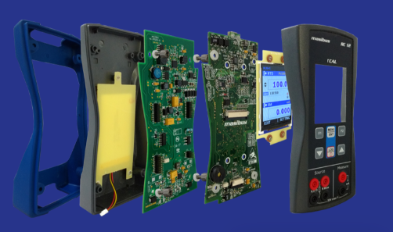

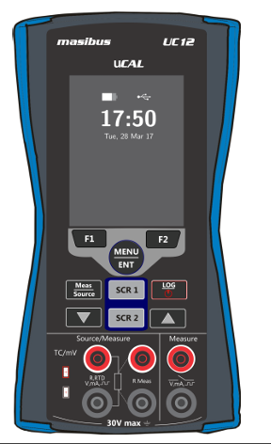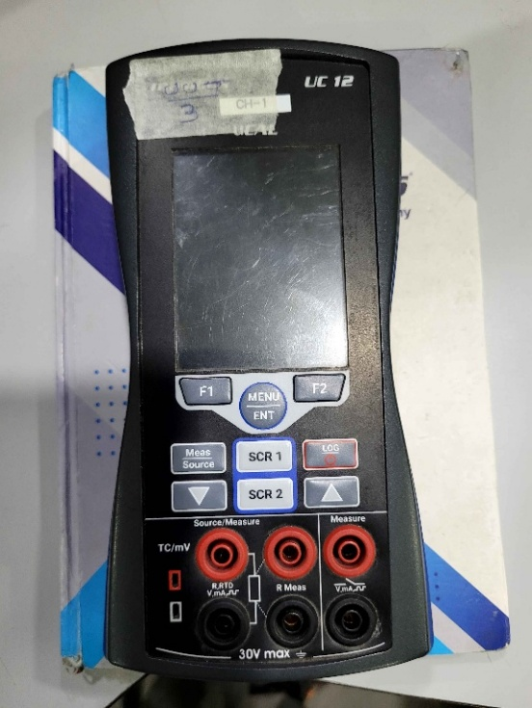

Figure 4.3 UC 12 internal Figure

Figure 4.1 UC12 Figure

Figure 4.2 UC12 Figure

## Problem and Weaknesses of UC 12 (Current System)

While the UC 12 calibrator is a reliable and compact instrument widely used for signal simulation and measurement, the current system has certain limitations and areas for improvement, especially in the context of modern industrial requirements. Limited Sensor Compatibility: The existing UC 12 system supports only a specific set if sensors and lacks flexibility for connecting newer or external sensor types without hardware modification.

* + 1. No Native External Sensor Interface: UC 12 does not provide built-in functionality to directly interface with external temperature or pressure sensors for real-time data input and calibration.
    2. No USB OTG Feature: UC 12 has a USB micro-b port but can’t communicate with other sensor using USB port enumerating as for data reception because it is configured to only data log to a USB Host machine like a laptop or a computer
    3. Lack of HART Integration: Although HART is widely used in smart instrumentation, the current UC 12 lacks onboard support for HART communication, limiting its ability to interface with smart field devices.

Figure 4.4 UC 12 USB port

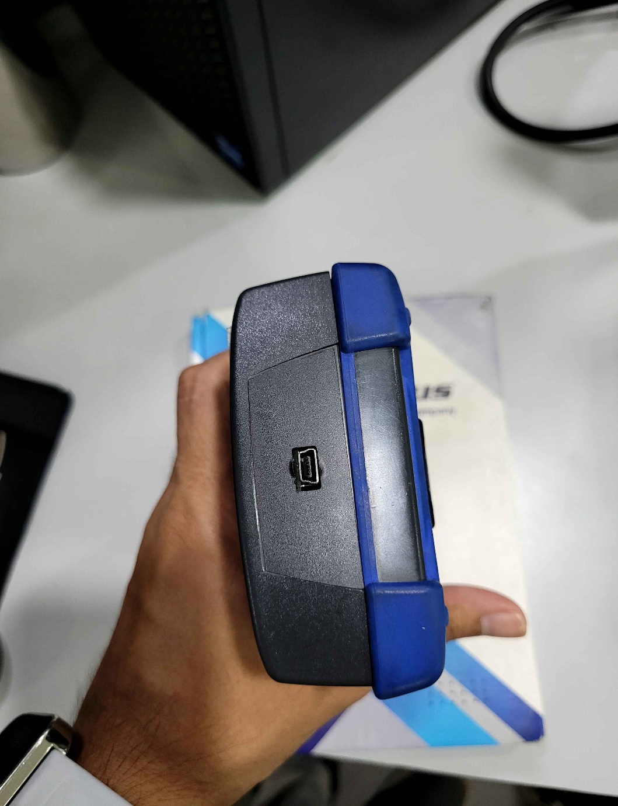

USB micro -B port

Figure 4.0.2USB micro -B port

* + 1. 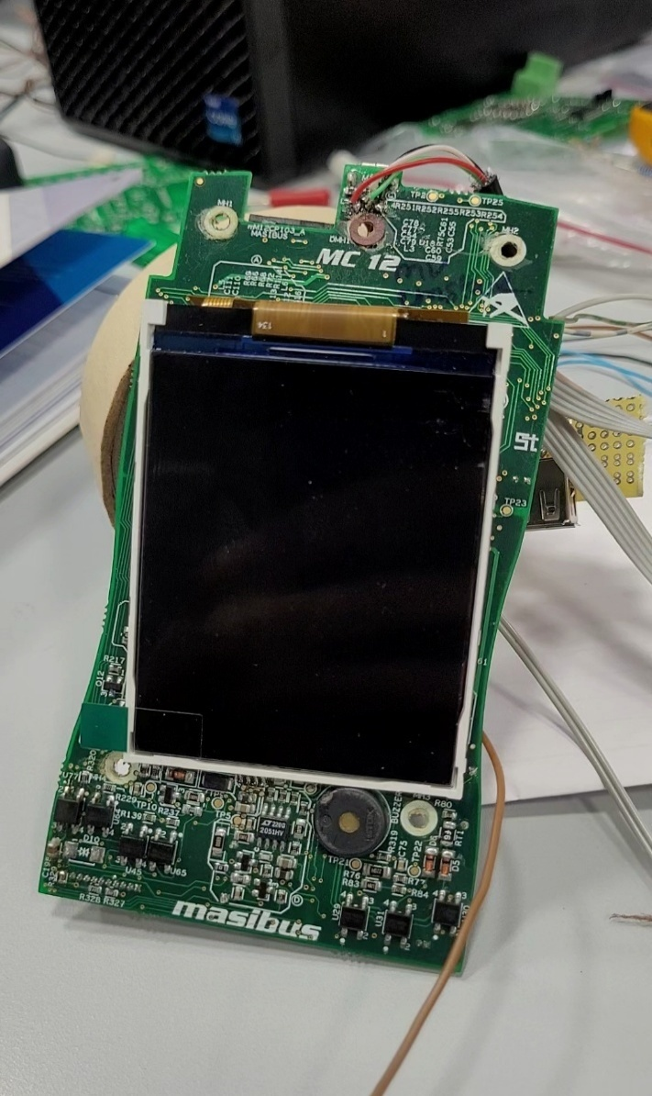Basic Display Output: The LCD used in the current system displays only limited parameters and lacks advanced visualization features like multi-line readings, sensor status indicators, touch screen which all modern calibrator uses for calibration.

Figure 4.5 UC 12 Old Display

## Requirements of New System

* + 1. External Sensor Interface: Ability to connect external pressure sensors directly to the UC 12 using different protocol available in sensor
    2. HART Communication Support: Implementation of the HART protocol to communicate with smart field devices.
    3. Real-Time Data Display: Display live sensor readings on the LCD screen for quick calibration reference.
    4. Multiple Sensor Support: Compatibility with a variety of sensor types (RTDs, thermocouples, etc.).
    5. LCD Upgrade: Using touchscreen LCD for better manoeuvring from different pages and setting without any confusion
    6. Ease of Use: Simple button-based control for sensor selection and reading refresh. The system should be user-friendly and require minimal training to operate
    7. Competition: competitor of company already provides all above features in their product and company wants to provide it in lower cost than them

## System Feasibility

* + 1. Inter facing Calibrator with different sensor and of different protocol helps user customer to calibrate various sensor with ease
    2. Developing a multifunctional calibrator helps customer to gain access to various different calibration methods and to different devices and on different protocol (such as HART and USB)
    3. New system can be implemented using existing system by redirecting certain wire, freeing certain ports on PCB and changing code of UC 12 to incorporate new changes such as Pressure sensor, HART communication protocol modem and new LCD
    4. New system will increase user of product as user are provided with latest calibration techniques at lower cost than competitor

## List Main Modules

To achieve the desired functionality of interfacing external sensors with the UC 12 and adding features like HART communication and LCD display, the new system will include the following modules and techniques:

* + 1. Microcontroller Unit (MCU): Acts as the central controller for processing sensor data and managing communication.
    2. Pressure Sensors (External): digital sensors to be connected for data acquisition and calibration.
    3. Signal Conditioning Circuit: Amplifiers, filters, and protection circuits for accurate sensor input reading.
    4. LCD Display Module: Used for real-time display of sensor values and system status.
    5. HART Communication Module: Enables digital communication with smart field devices using the HART protocol because controller does not have HART module built in it
    6. Power Supply Unit: Upgrade existing power supply to power new LCD and increase battery life
    7. HART Protocol Implementation: Software routine for decoding and encoding HART communication frames and formation and decoding of DD file of communication with other HART enabled devices
    8. LCD Interfacing Code: Microcontroller-based routines to control the LCD for clear data visualization.

# CHAPTER 5: System Design



Figure 5.1 UC 12 basic working

## System Design & Methodology

Methodology Followed:

* + 1. Requirement Analysis: Defined key project objectives: external sensor interface, HART communication, and LCD display
    2. Hardware Selection & Circuit Design: Chose suitable sensors and microcontroller. Designed and simulated the signal conditioning and interfacing circuits.
    3. Firmware Development: Developed embedded code for sensor data reading, calibration processing, LCD control, and HART message handling.
    4. Integration & Testing: Connected all modules and tested sensor readings and LCD output Debugging & Optimization: Optimized ADC sampling, display refresh rate, and power usage.

## Block diagram

Figure 5.2 New Block Diagram of Multifunctional calibrator

This block diagram illustrates the architecture of an advanced signal calibrator system that integrates both new and existing components. It includes external pressure and barometric sensors, HART communication via modem, signal conditioning circuits, data converters (ADC/DAC), memory and RTC modules, and a touchscreen interface. Signal paths are managed through multiplexers and offset circuits, while various output modes (e.g., mA, mV, RTD, TC) are enabled through dedicated conditioning and switching blocks. The system supports real-time display, feedback measurement, and configurable signal sourcing for industrial calibration tasks.

## Interface Design

### USB

* + - 1. For interface of board with computer we use a CCS studio software which has all code of UC 12 in a folder
      2. For dumping code in UC 12 board, we use a special type of instrument called a debugger which has pin connected to pin of UC 12 board
      3. CCS allow user to read data in register as well as write a specific value in specific register of the controller
      4. Additionally, we used MBUS software for writing specific value in a register of controller
      5. For checking data from UC 12 we used Hterm, Tera term etc serial monitoring tools to observe data

### HART interface

* + - 1. For HART communication we used HART to UART converter because controller does not have a HART module

### LCD

* + - 1. For LCD GUI we used DWIN’s DGUS software which provides an easy way to make GUI by uploading images and editing them for communication with UC 12 we used UART, RS-232 Communication protocol as LCD supports it

Figure 5.3 Debugger and Connection

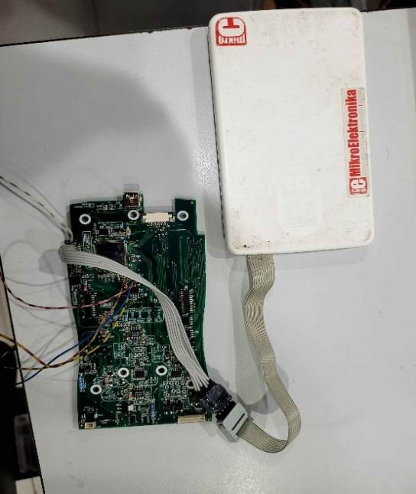

Debugger

# CHAPTER 6: IMPLEMENTATION



## Implementation Platform

### Hardware Environment:

* + - 1. Microcontroller: Texas Instrumentation controller (ARM Cortex-M4 based)
      2. External Sensor: Wika CPT 6100(USB, RS-485, RS-232)
      3. Display: Dwin Touchscreen LCD (UART/RS-232 interface)

### Software Environment:

* + - 1. Programming Language: Embedded C
      2. 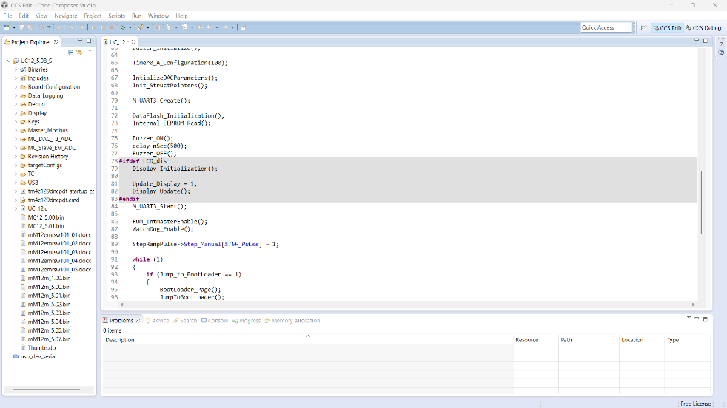Development Environment: Code Composer Studio (TI)

Figure 6.1 CCS UI

* + - 1. Compiler: TI ARM Compiler (included in CCS)
      2. Debugging Tools: JTAG Debugger, UART Serial Monitor

## Implementation Process

Implementation of project was done in different phases of with different equipment

### Phase 1 – External Sensor Interface:

* + - 1. For sensor interface prior works was to study which sensor is needed and best for calibration process and with high accuracy (0.01%)
      2. After researching of pressure sensor found sensor with all requirement. it used USB and RS-485 communication for sending and receiving data from calibrator
      3. But controller does not have free UART and so we decided to communicate with USB protocol
      4. USB protocol can only be possible when there is Host and Device
      5. 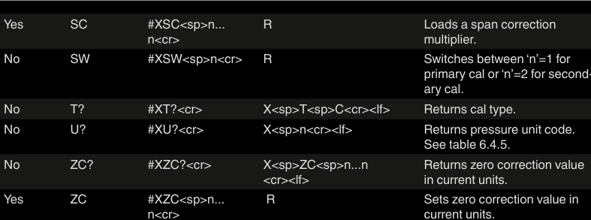To pressure senor responds to commands over USB from host

Figure 6.2 Commands supported by pressure sensor

* + - 1. So, for pressure data calibrator needs to send a command (structed ascii character)
      2. For DATA logging in computer controller should behave as device and for pressure sensor communication it should behave as host . both can be possible in OTG mode
      3. 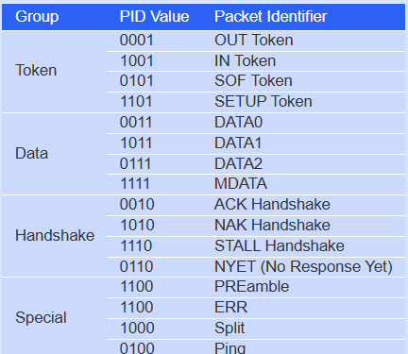USB host device sends tokens to device when it needs data and then accepts device information

Figure 6.3 USB packet list

* + - 1. If host mode is not enabled and device sends data to host It would not accept any data and no communication happens
      2. 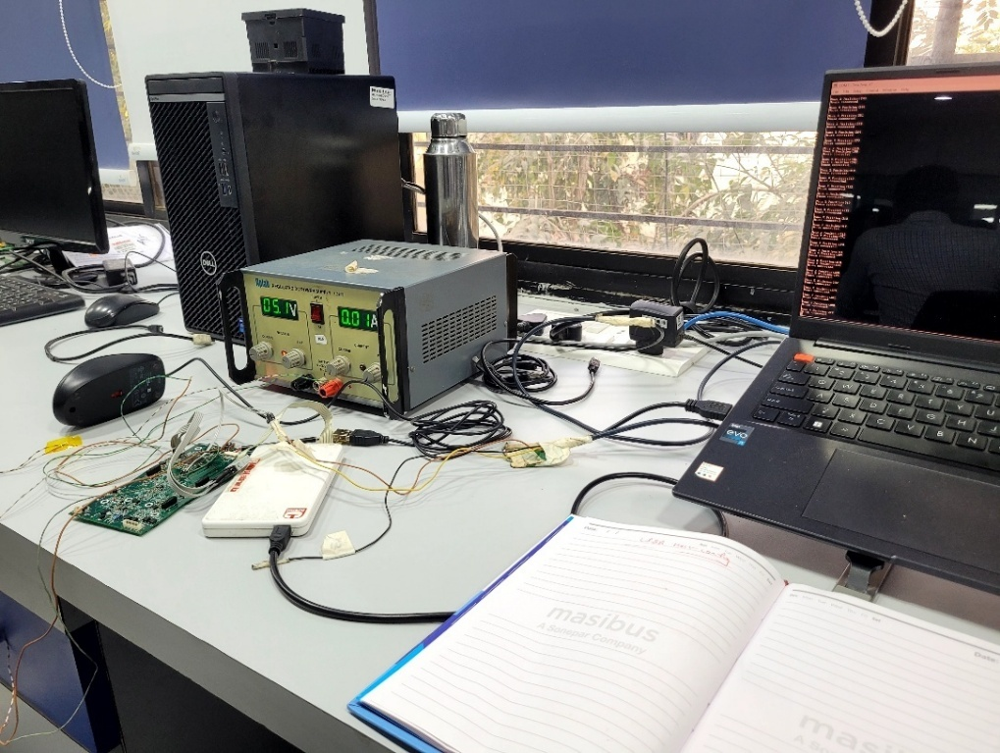Further, implemented a demo code of mouse and received position of mouse and printed of UART pin to observe

Figure 6.4 Mouse Setup

* + - 1. 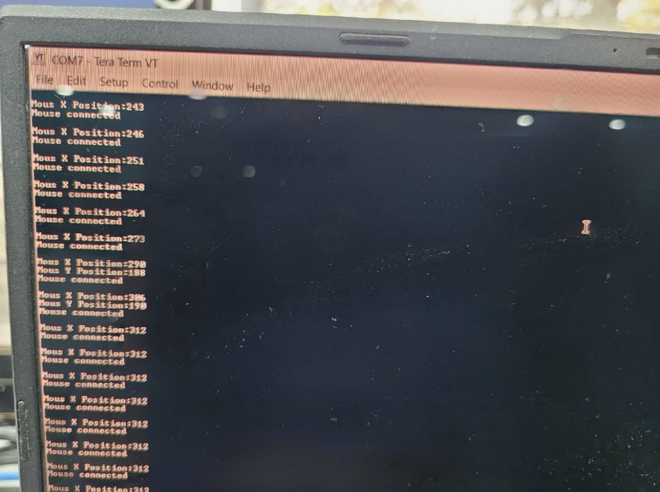This provided evidence that controller can be configured as USB host with changes in code by enumerating to host

Figure 6.5 Position in serial monitor

* + - 1. Changes over hardware and software were done to start and communication over USB protocol started
      2. When data is send by host UC 12 board a buzzer was ranged and when Device UC 12 board received correct command buzzer was ranged
      3. So USB communication happened from one UC12 board to another which was simulating pressure sensor
      4. For communication between two UC 12 main board we used a USB mini B to USB mini B cable because both have same port
      5. Microcontroller used in board does not provide 5 V DC supply in USB channel and a device host is enumerated when 5 V DC is received at USB port as there is a pin for detecting of 5V.
      6. This problem can be tacked in two methods
* We can force Host and force Device by calling a specific case from driver. This makes the board Host or Device without detecting a 5V DC at port. Communication will still start as it does not depend of 5V
* 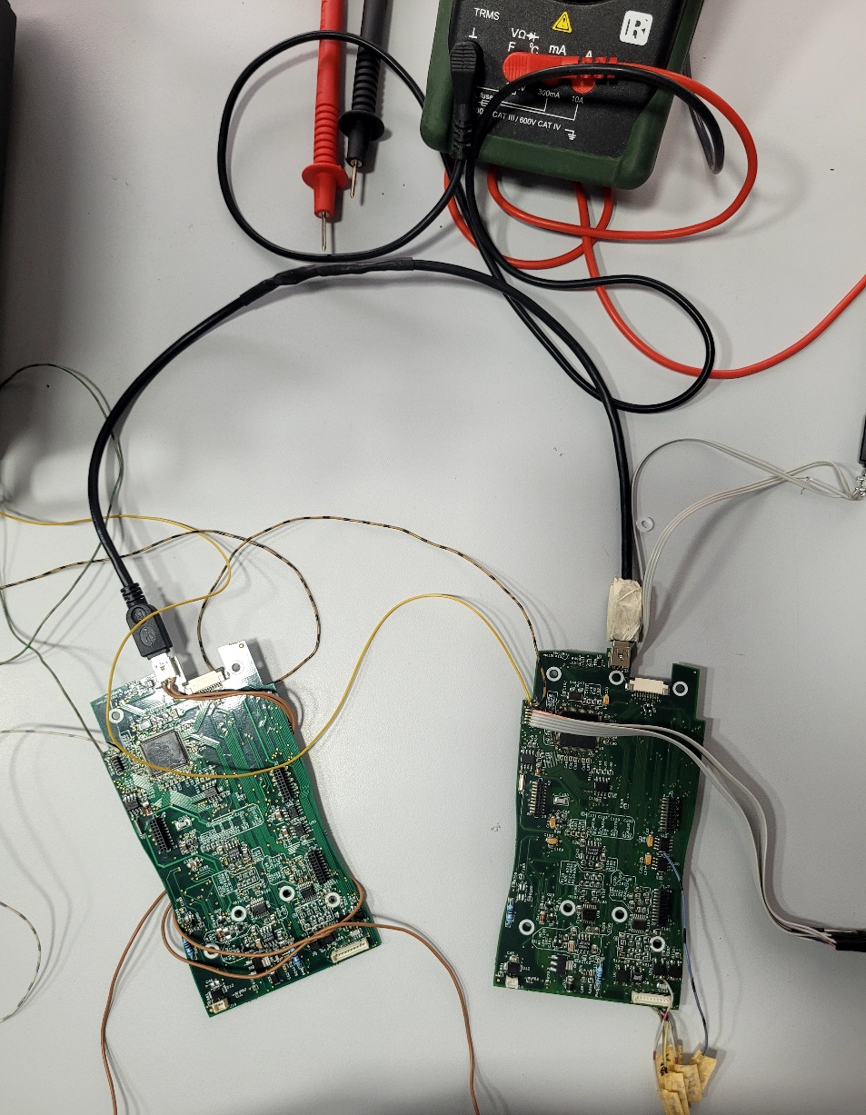We can provide 5V DC using External Power supply. This can be done but can’t always carry 5V DC power supply

Figure 6.6 UC 12 connection with another board

* + - 1. For this project, option one was chosen and made force host and force device
      2. This process made communication passible

### Phase 2 - HART communication

* + - 1. For HART Communication, Research and meeting was conducted and different Q and A email happened with FieldComm group (founder of HART communication)
      2. HART communication protocol Is based of FSK of Digital signal in 4-20 mA analog signal which helps in forming 2 information at once
      3. HART communication also provide power to all field devices present in loop as well as send and receive data in same loop \
      4. It works in host and device method like USB
      5. HART communication allows 2 host to be present in a loop and 15 devices
      6. Communication of information happens when host send command in loop with address field device corresponding to address will respond back with information
      7. In real plant primary Host would be a PLC device which collect field device data and stores.
      8. Goal of calibrator to be a secondary host in loop and calibrate field device in loop one by one

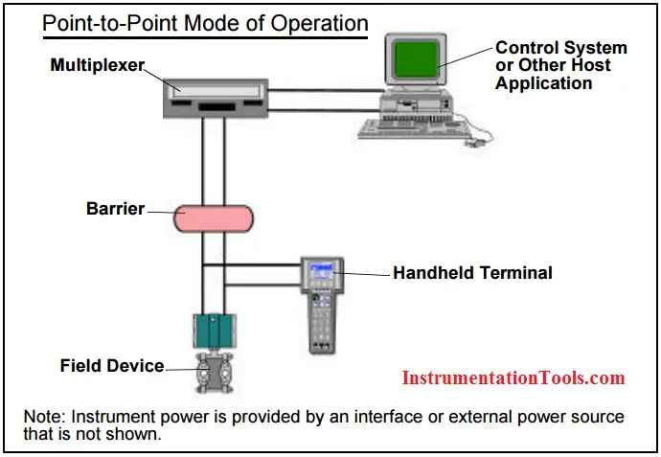

Figure 6.7 HART device calibration

* + - 1. A HART enabled Calibrator needs to identify which device is been connected and information like manufacturer max and min calibration point, span value etc. For this manufacturer create DD files (Device Description) which contains all information
      2. DD file are written in DDL language which has a syntax for containing variable and values.
      3. This file is mode in text editor or in software provided by FieldComm group which generates a binary file in format of. FMS8 and a symbol file .Sym
      4. This file are read by host (calibrator) and decoded to extract information
      5. FieldComm charges money to provide software and licences all HART enabled devices

### Phase 3 – LCD interface

* + - 1. For making a multifunctional calibrator we need to add external sensor interface, HART communication and a bigger touchscreen LCD provided by competitor.
      2. After meeting and Research LCD screen of DWIN company was chosen as it fit requirement
      3. LCD screen was of 5.7 inch(diagonal) 640 x 480 pixels and capacitive touch screen
      4. For communication we provided information through UART pins as LCD supports I2C , UART , RS-232 protocol For UI of LCD a software was provided by LCD manufacture called DGUS which has capability to build UI. The project fill be dumped in LCD using SD card.
      5. In software we need to make a image and give functionality and of button and dump in LCD
      6. For UI we referred competitor such as Beamax’s MC6 , WIKA’s CPH8100 product
      7. Referring them we started to build our own images for UI of the calibrator 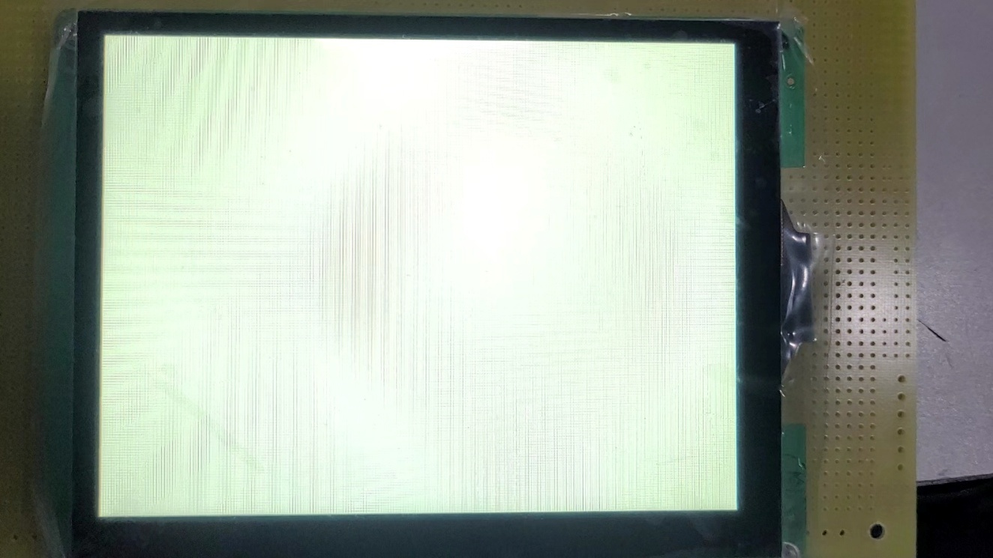

Figure 6.8 New LCD

* + - 1. For showing data on LCD or to receive data of touch a command is generated by controller or by LCD (also contains a controller).
      2. 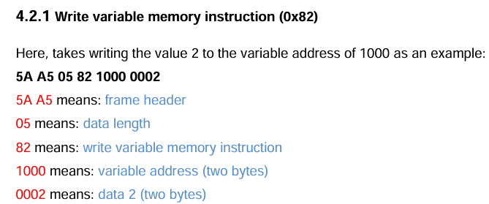These commands are received in UART pin of LCD where command will be parsed into different part which signifies different information

Figure 6.9 Command Example

* + - 1. For receiving these commands, we wrote code to check header is 5A A5.
      2. When header is correct, we can read data at 5th and 6th position of command these
      3. For sending same method will be followed this will be followed
      4. 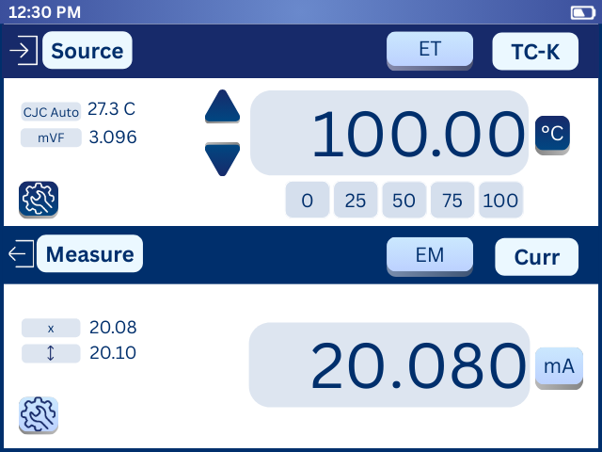For UI made images of different layout and after meeting we concluded a flow of UI and colour them of the UI which matches companies colour them

Figure 6.10 Home screen of LCD

# CHAPTER 7: CONCLUSION



## Overall Analysis of Internship / Project Viabilities

The internship and project work carried out in collaboration with Masibus Automation and Instrumentation Pvt. Ltd. has proven to be both technically viable and industrially relevant. The integration of external sensors with the UC 12 calibrator, along with the implementation of HART communication and touchscreen interface, reflects strong alignment with real-world industry needs.

Key Points of Analysis:

* + 1. Technical Feasibility
* The use of standard industrial components like ADCs, DACs, MUX, and HART protocol ensures compatibility with current calibration practices.
* Modular hardware and software design enable easy upgrades, maintenance, and expansion.
  + 1. Industry Relevance
* The project addresses real-world calibration challenges by allowing flexible sensor interfacing.
* Support for both analog and digital (HART) communication enhances field applicability.
  + 1. Skill Development
* The internship provided hands-on experience in embedded system design, protocol development, hardware interfacing, and technical documentation.
* It also enhanced understanding of instrumentation standards and embedded C programming.
  + 1. Innovation & Uniqueness
* The ability to interface multiple types of sensors through a single calibrator platform adds versatility.
* Incorporating a touchscreen and USB communication introduces user-friendly features not always present in traditional systems.

## Problem Encountered and Possible Solutions

* + 1. First problem faced was how with CCS software as it didn’t install necessary driver for code dumping
    2. When using demo code of mouse, different pin was configured for output and was working of different clock frequency as UC 12 has different internal clock. to solve we changes clock frequency as used in UC 12 and turned in only necessary pin for communication
    3. While debugging mouse using serial monitor, we chose wrong baud rate and resulted in garbage data at serial monitor

## Conclusion

The internship at Masibus Automation and Instrumentation Pvt. Ltd. provided a comprehensive and practical learning experience in the domain of embedded systems and industrial instrumentation. The project focused on the integration of external sensors with the UC 12 calibrator, along with the implementation of key technologies such as HART communication, touchscreen LCD interface, and USB connectivity.

Throughout the course of the internship, I gained valuable insights into real-world system design, sensor calibration techniques, and protocol implementation. The challenges faced during development—from hardware interfacing to communication synchronization—were effectively overcome through research, teamwork, and technical guidance.

The successful development and testing of the proposed system demonstrate its potential as a scalable and industry-relevant solution. It not only fulfills the required functionality but also opens opportunities for further enhancements such as cloud integration, wireless communication, and multi-sensor compatibility.In conclusion, this project not only strengthened my technical foundation but also instilled a deep understanding of industrial practices, making the internship a truly enriching and career-shaping experience.

## References

* + 1. Texas Instruments Microcontroller Datasheet *(https://www.ti.com/product/DAC8740H*
    2. Masibus Automation and Instrumentation Pvt. Ltd. – Product Manuals and Technical Brochures([*https://www.masibus.com*](https://www.masibus.com/)*/)*
    3. HART Communication Foundation – HART Protocol Overview  
       ([*https://www.fieldcommgroup.org/technologies/hart*](https://www.fieldcommgroup.org/technologies/hart)*)*
    4. TivaWare™ Peripheral Driver Library User’s Guide – Texas Instruments  
       (Available in Code Composer Studio and on TI Resource Explorer)
    5. ADS1247 – 24-Bit Analog-to-Digital Converter Datasheet – Texas Instruments ([*https://www.ti.com/product/ADS1247*](https://www.ti.com/product/ADS1247))
    6. DAC8560 – 16-Bit Digital-to-Analog Converter Datasheet – Texas Instruments(https://www.ti.com/product/DAC8560))
    7. Atmel AT45DB041E Data Flash Memory Datasheet  
       ([*https://www.microchip.com/en-us/product/AT45DB041E*](https://www.microchip.com/en-us/product/AT45DB041E))
    8. Embedded C Programming for ARM Cortex-M Microcontrollers – Textbook & Online Tutorials
    9. USB CDC Class Communication Tutorial – Tiva C Series (TI E2E Community & GitHub)
    10. Practical Embedded Systems – Raj Kamal, McGraw Hill Education
    11. FieldComm Group – HART Device Description Language (DDL) Specification  
        *(*[*https://www.fieldcommgroup.org/technologies/hart*](https://www.fieldcommgroup.org/technologies/hart))
    12. DDIDE – Device Description Integrated Development Environment (from FieldComm Group)([*https://www.fieldcommgroup.org/products/dd-ide*](https://www.fieldcommgroup.org/products/dd-ide))
    13. DMG64480T057_01WN User Manual ([*https://www.dwin-global.com/5-inch-smart-lcd-touch-panel-dmg64480t057_01w-industrial-grade-product/*](https://www.dwin-global.com/5-inch-smart-lcd-touch-panel-dmg64480t057_01w-industrial-grade-product/))
    14. DGUS II Development Software – DWIN GUI Software([*https://www.dwin-global.com/product/software/*](https://www.dwin-global.com/product/software/))

# POSTER